Does heroin use change addicts’ brains?
Li, Q et al (2013) Abnormal function of the posterior cingulate cortex in heroin-addicted users using resting-state & drug-cue stimulation task.

Background Research: this is what was known prior to Li et al’s study

Use a pencil to label the brain diagram below where you think the following brain structures are:

posterior cingulate cortex

hippocampus

amygdala

prefrontal cortex

Use a pencil to name which of these brain structure has the following function:

* like a relay station sending sensory information to the correct part of the cerebral cortex
* involved in learning & long term memory
* involved in emotions, emotional behaviour & motivation
* enables complex processing (thinking, reasoning) & varied behaviour
* involved in anticipating reward, controlling impulses & empathy
* involved in forming emotions
* involved in pain perception & episodic memory

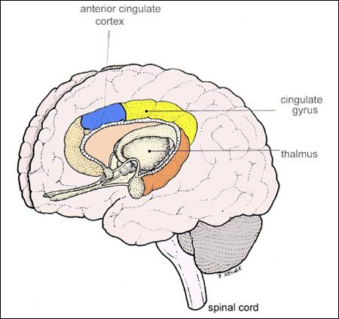

Introduction to the study
Heroin is a drug that is produced from the poppy plant. Heroin stimulates the release of the neurotransmitter dopamine & causes a sensation of well-being. Users continue to take heroin for the rewarding experiences & if addicted, they will crave the drug. Heroin addicts’ primary purpose in life (motivation) is to seek & use heroin.
During an addict’s drug use, they start to associate specific things in their environment with the pleasurable effects of their drug use. For example, a person addicted to nicotine may associate the smell of coffee with having a cigarette during a coffee break and so crave a cigarette when they smell coffee. A person addicted to alcohol may associate the sound of music and large crowds of people with having a drink with friends at a pub and so crave a drink when they pass a pub. In these examples the coffee & the pub are CUES that are associated with the drug use and so trigger the craving.
Q1. Think back to Learning Theory. Which type of learning is involved here?

Q2. What types of cues might trigger craving in a heroin addict?

Q3. What types of cues are unlikely to trigger craving for heroin?

Li et al were interested in the posterior cingulate cortex and the areas it connects with as it had not been studied in relation to drug craving. They used an fMRI scanner to measure the activity of these areas
Q4. How does an fMRI scanner show activity in the brains of people studied?

Understanding the study
Li et al wanted to see how active the connections from the posterior cingulate cortex were to adjacent areas of the brain. The brain activity was measured in a ‘resting-state’ and then participants were exposed to photos of drug paraphernalia (eg syringes; cooking heroin on a spoon) and their brain activity was measured again.

Q5. Why did Li et al measure the participants’ brain activity in a ‘resting-state’?

Q6. What could this resting state involve?

Q7. Why was the brain activity of the participants measured after being exposed to pictures of drug-related items?

Li et al studied the brain activity of 14 heroin-addicted men who were in a drug rehabilitation centre & had been ‘clean’ (off drugs) for an average of 89 months as well as a control group who had never been addicted to heroin.
Q8. Why was it important to measure the brain activity of a control group?

Q9. The control group were matched to the ex-addict group. What would be good factors to match on?

Q10. Li et al also studied the ex-addicts ‘craving’ for heroin. How could you measure ‘craving’? Give enough detail that another person could measure this.

Q11. Li et al predicted that there would be differences in WHEN the ex-addicts had a craving for heroin & these predictions were confirmed. Read through ‘Understanding the Study’ again. When would you predict that the ex-addicts would feel more craving?

At this point it is a good idea to read the study in your text

Q12. This is a quasi-experiment. What is the naturally occurring IV?

What is the DV?

What are the controlled variables?

Results
Q13. Read your text before completing the table for the ex-addicts:
Measure | Before seeing cue-inducing pictures | After seeing cue-inducing pictures
Craving

Q14. Read your text before completing the table for the ex-addicts AND control group:
Measure of connectivity between PCC & adjacent areas | Ex-addicts | Control group of non-addicts
Resting state
Cue-inducing pictures

Q15. Furthermore there was a significant correlation (rho = 0.60, p < 0.05) between:
Variable 1 = how long the ex-addict had been a heroin user
Variable 2 = degree of connectivity between the PCC & adjacent areas when at rest

What type of correlation was shown?

Conclusion
Heroin users have abnormally / significantly different connectivity between the posterior cingulate cortex and adjacent areas. As there is a positive correlation between the PCC connectivity & how long heroin has been used, this suggests that the heroin addict brain is changing / being damaged by their heroin use. Li et al suggest that the posterior cingulate cortex appears to have an important role in craving & drug-seeking behaviour.

Q16. Use GRAVE to evaluate this study.

